**Task 6 iNeuron**

Imported the database using bulk load:

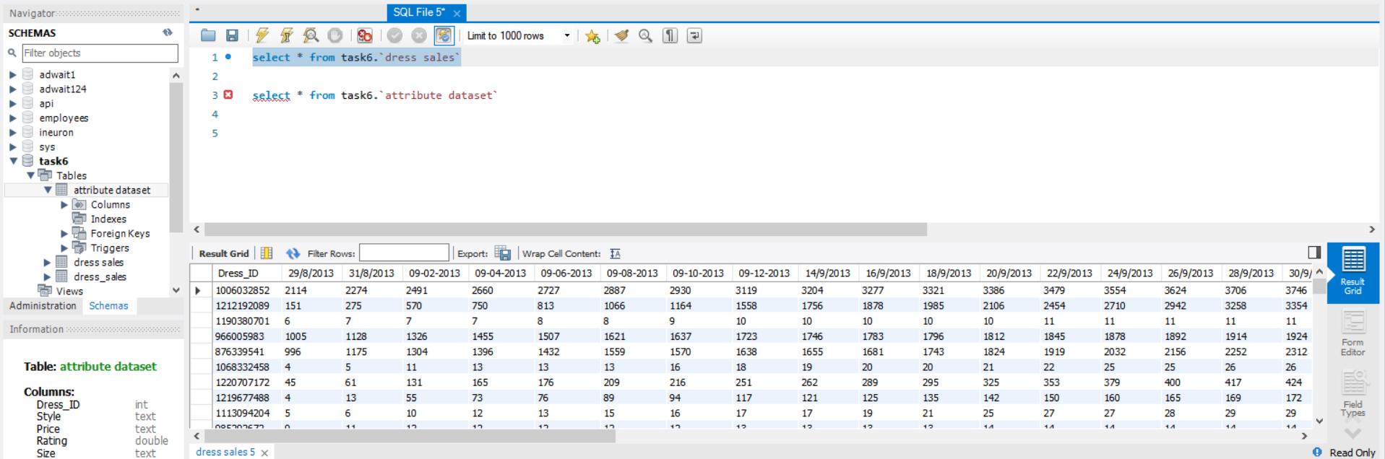

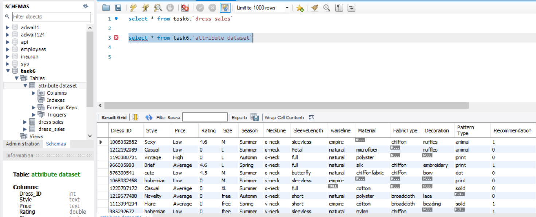

Operations Performed:

